M2.3 Assignment
Course: CSD310 – 340A
Prepared By: Mirach Erkol
Date of Report: 11/2/2025

https://github.com/Mikey5007/csd-310.git

M2.3 Assignment Part 1: ERD Diagram

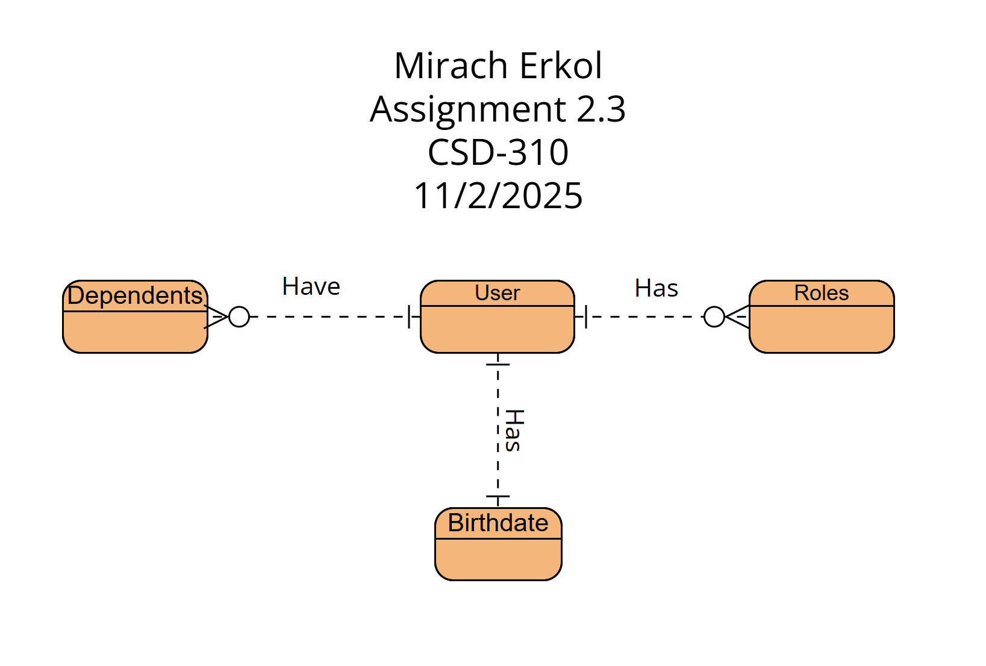

M2.3 Assignment Part 2: NoSQL Structure

{
"user": {
"first_name": "",
"last_name": "",
"birthdate": "",

"roles": [
"",
""
],

"dependents": [
{
"name": "",
"relationship": ""
},
{
"name": "",
"relationship": ""
}
]
}
}

Mikey5007/csd-310: CSD

